SUPERTRAMP’S ROGER HODGSON,
THE ENDURING VOICE AND COMPOSER OF THE BIGGEST HITS, BEGINS
BREAKFAST IN AMERICA WORLD TOUR

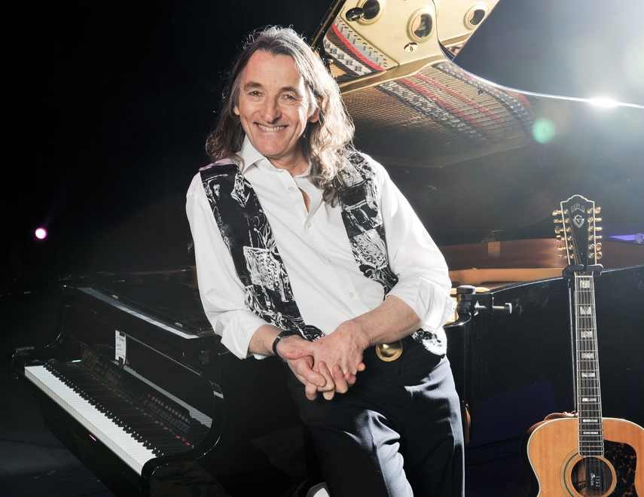

Roger Hodgson, known for all of the classic Supertramp mega-hits that he wrote, composed and sang, embarks on a new world tour that kicked off June 12 in Austria and ends on November 18 in Vancouver. With venues selling out quickly, it is amazing how his timeless songs and Roger’s mesmerizing performances continue to connect in powerful ways to bring fans everywhere back for more year after year.

The enduring appeal of Hodgson’s compositions - songs like “Give a Little Bit,” “The Logical Song,” “Dreamer,” “Take the Long Way Home,” “Breakfast in America,” “It’s Raining Again,” “School,” “Hide in Your Shell,” “Fool’s Overture,” “Had a Dream” and “In Jeopardy,” continues to thrill and be celebrated by multi-generations, creating yet another sold out tour.

Roger Hodgson co-founded the legendary group almost five decades ago. Album sales now exceed 60 million. Their hugely successful album Breakfast in America will celebrate its 40th anniversary next year. Touring consistently to packed and appreciative audiences worldwide, Hodgson continues to be honored by critics and fans alike for his music and performances as well as his philanthropy.

Roger on tour: https://www.youtube.com/watch?v=WMLNeSbtVN0

Roger Hodgson Official Sites
http://www.RogerHodgson.com
https://www.Facebook.com/RogerHodgson
https://www.Twitter.com/RogerHodgson
https://www.YouTube.com/RogerHodgson
https://www.Instagram.com/RogerHodgson

ROGER HODGSON
2018 Tour Dates:

Click HERE for VIP* Packages on Roger’s Store

EUROPE
Jun 12 Festung Kufstein, Austria
 Jun 14 Volkshaus, Zürich, Switzerland SOLD OUT! VIP
Jun 15 Festi'neuch - Neuchâtel Openair Festival, Switzerland TICKETS
Jun 16 Le Forum de Liège, Liège, Belgium SOLD OUT! VIP
Jun 17 Stone Free Festival at The O2, London, England TICKETS
Jun 21 OverOslo Festival, Oslo, Norway SOLD OUT!
Jun 22 Wrightegaarden, Langesund, Norway TICKETS
Jun 24 Grieghallen, Bergen, Bergen, Norway TICKETS VIP
Jun 26 Luxor Theater, Rotterdam, Netherlands SOLD OUT! VIP*
Jun 28 Koninklijk Theater Carré, Amsterdam, Netherlands SOLD OUT! VIP*
Jun 29 Koninklijk Theater Carré, Amsterdam, Netherlands SOLD OUT! VIP*
Jun 30 RETRO C TROP Festival, Tilloloy, France TICKETS

USA and Canada
Jul 13 Sugar House Casino, Philadelphia, PA, USA SOLD OUT! VIP*
Jul 14 Spyglass Ridge Winery, Sunbury, PA, USA TICKETS VIP
Jul 15 American Music Theatre, Lancaster, PA, USA TICKETS VIP*
Jul 17 Maryland Hall for the Creative Arts, Annapolis, MD, USA SOLD OUT! VIP*
Jul 18 Bergen Performing Arts Center, Englewood, NJ, USA TICKETS VIP*
Jul 20 Les Grandes Fetes TELUS in Parc Beausejour, Rimouski, Canada TICKETS
Jul 21 La Fete du Lac des Nations Festival, Sherbrooke, Canada TICKETS
Jul 24 Humphreys Concerts by the Bay, San Diego, CA, USA TICKETS VIP*
Jul 25 The Pacific Amphitheatre, Costa Mesa, CA, USA TICKETS
Jul 27 Chukchansi Gold Resort and Casino, Coarsegold, CA, USA TICKETS VIP*
Jul 28 Snoqualmie Casino, Snoqualmie, WA, USA TICKETS VIP

EUROPE
Aug 9 Sildajazz International Jazz Festival, Haugesund, Norway TICKETS
Aug 11 Summar Festivalurin, Faroe Islands, Denmark TICKETS
Aug 14 Calle de la Plaza do Toros, Alicante, Spain TICKETS
Aug 16 Tio Pepe Festival, Jerez de la Frontera, Spain SOLD OUT
Aug 17 Plaza do Toros de Ubeda, Úbeda, Spain TICKETS
Aug 18 Cap Roig Festival, Palafrugell, Spain SOLD OUT!
Aug 20 Kunstrasen Bonn Gronau, Bonn, Germany TICKETS VIP
Aug 21 Open-Air Parkbuhne im Clara Zetkin Park, Leipzig, Germany TICKETS VIP
Aug 23 Stadtpark Open Air, Hamburg, Germany TICKETS VIP
Aug 24 Amphitheater, Hanau, Germany TICKETS
Aug 25 Seaside Festival, Spiez, Switzerland TICKETS
Aug 26 Weserwiesen Open-Air, Beverungen, Germany TICKETS VIP
Aug 28 Musical Theater, Bremen, Germany SOLD OUT! VIP
Aug 29 Giebener Kultursommer, Giessen, Germany TICKETS
Aug 31 Sauerlandpark, Hemer, Germany TICKETS
Sept 1 Rosengarten, Mannheim, Germany TICKETS VIP
Sept 2 Zeltfestival Ruhr, Bochum, Germany TICKETS
Sept 4 Kurpark Classix, Aachen, Germany TICKETS
Sept 6 Kultur & Kongresszentrum Liederhalle, Stuttgart, Germany TICKETS VIP
Sept 7 Munich Philharmonic, Munich, Germany TICKETS VIP
Sept 8 Berlin Tempodrom, Berlin, Germany TICKETS VIP

CANADA and USA
Oct 26 Grand Theatre, Québec, Canada SOLD OUT! VIP
Oct 27 TD Place, Ottawa, Canada TICKETS VIP
Oct 29 Theatre St-Denis, Montréal, Canada TICKETS VIP
Oct 30 Place des Arts, Montréal, Canada SOLD OUT! VIP
Oct 31 Theatre St-Denis, Montréal, Canada TICKETS VIP
Nov 2 Casino Rama Resort & Casino, Rama, Canada TICKETS (on sale June 16)
Nov 3 Casino Rama Resort & Casino, Rama, Canada TICKETS (on sale June 16)
Nov 6 Potawatomi Hotel & Casino, Milwaukee, WI, USA TICKETS VIP*
Nov 7 Potawatomi Hotel & Casino, Milwaukee, WI, USA TICKETS VIP*
Nov 8 Potawatomi Hotel & Casino, Milwaukee, WI, USA TICKETS VIP*
Nov 9 Potawatomi Hotel & Casino, Milwaukee, WI, USA TICKETS VIP*
Nov 12 River City Casino & Hotel, St. Louis, MO, USA TICKETS VIP
Nov 13 River City Casino & Hotel, St. Louis, MO, USA TICKETS VIP
Nov 15 Grey Eagle Resort & Casino, Calgary, Canada TICKETS VIP
Nov 16 River Cree Resort & Casino, Enoch, Canada TICKETS VIP
Nov 17 River Rock Casino Resort, Vancouver, Canada TICKETS VIP
Nov 18 Hard Rock Casino, Vancouver, Canada TICKETS VIP

Roger on tour: https://www.youtube.com/watch?v=WMLNeSbtVN0

There are few vocalists instantly recognizable from the first few bars of a song but Roger Hodgson is certainly one of that unique group. The singer/songwriter of Supertramp, his voice is as unmistakable as the distinct keyboard sound of his early hits.
The Times- London, Review from The Royal Albert Hall Concert

Overjoyed grins and rhythmic claps, accurate whistling and enthusiastic screams of jubilation accompanied with the voice that brings goosebumps through his work. At the end, the completely enthused listeners didn’t want to let the world star go.
Aachen Nachrichten, Bernd Büttgens

Beautiful. That's the word that just keeps popping into your head when watching Roger Hodgson perform. Whether it's the melodic complexity of his songs, the harmonies he weaves with his band, the lyrics that sweep you away or his ability to still command the incredible upper range of his voice, beautiful was what kept coming to mind over and over again during his performance. 'Breathtaking' might also apply. 'I want more' certainly would."
Mesa Classic Rock Music Examiner, Ten Hansen

From his fingers came the magic melodies that flowed from the heart, and as I believe: touched hearts. There was a special bond between the artist and the audience. There was something genuinely mystical about it. Something that only happens when dealing with real art. Beautiful show.
Blog Nawiedzonego, Andrzej Gwoździk

Media contact:
Linda Tyler, Harmonic Management, HarmonicManagement@me.com
Shakti Shivaya, Harmonic Management, Shakti@RogerHodgson.com

